Sample Organizational Structures for Content
Overview
Information architecture is the practice of deciding how to organize, structure, and label content for a website, application, or other interface to support usability and findability of the information that the interface contains. More simply, information architecture is about helping people understand their surroundings and find what they’re looking for, and it forms a foundation for good user experience. End-results of information architecture are:
- Navigation menus: a set of options that facilitate a user moving through the website or application and browsing the content.
- Sitemaps: a visual or textually organized model of a website’s content that allows users to navigate through the site, typically organized in hierarchical fashion (similar to a table of contents).
Note: While many websites do not provide a sitemap link for their users they may still have a sitemap page. A sitemap is important because it tells search engines about the content that you have on your site and how often it’s updated, making it easier for the search engines to include it in search results.
- Taxonomies: a process or system of classification used to organize concepts into an easy-to-remember framework for discussion or analysis. More simply put, it is a way for naming (labeling) and organizing things, usually in the form of a hierarchy, into groups that share similar characteristics. Taxonomies facilitate retrieval and findability in both browsing and searching, helping users quickly find the information they are looking for.

- Metadata: data that describe and give information about other data, which make finding and working with particular instances of data easier. For example, author, title, keywords, date created, and file size are examples of very basic document metadata. Having the ability to filter using metadata makes it much easier for someone to locate a specific document.
Below are selected examples of organizational structures used by particular websites (see their navigation menus, sub-menus, or page-level categories, for example) or taxonomies employed by particular projects or websites. Note that these are illustrative examples only; we cannot endorse any as “model” examples that meet their particular users’ needs.

MEASURE Evaluation
https://www.measureevaluation.org/

MEASURE Evaluation’s main navigation menu is located in the upper right corner of the webpage (outlined in turquoise the screenshot below). Main menu categories and their sub-menus are repeated in the footer, a design trend that many websites are starting to use.

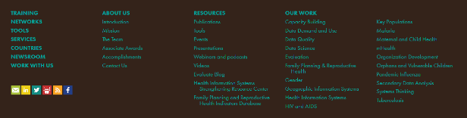
The sitemap link is at the very bottom of the page (also outlined in turquoise) and takes you to a hierarchical display of all the pages on the website.
Sitemap

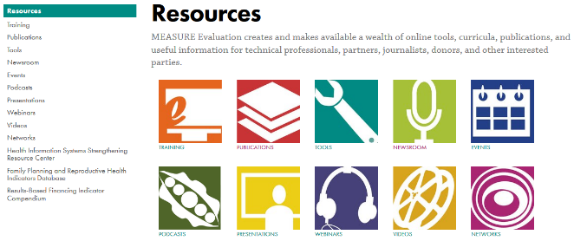
The Resource section of MEASURE Evaluation’s website displays the taxonomy developed for categorizing the many different types of resources that can be found on the website.

Selecting Publications from the Resources page and clicking on a publication title link displays the metadata for the publication.

For example, Bangladesh Mayer Hashi II – 2015 Baseline Survey Report displays the Author(s), Year, Abstract, cover image, PDF link, and keywords assigned to this document.

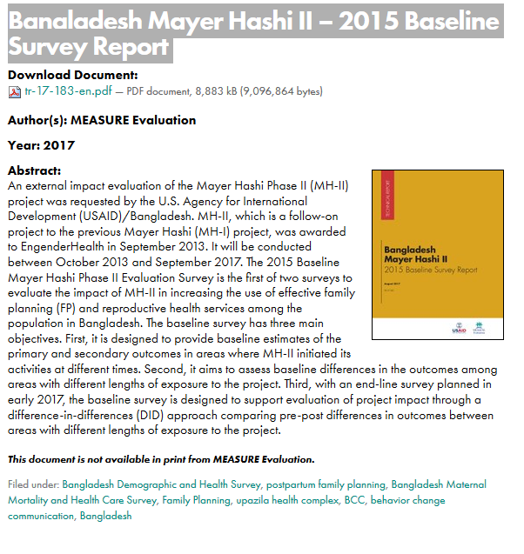

Other Examples of Information Architecture Outputs

Ministry of Health, Republic of Kenya (navigation menu)
http://www.health.go.ke/

Management Sciences for Health (navigation menu)
http://www.msh.org/

E2A Evidence to Action (sitemap)
https://www.e2aproject.org/sitemap/

WHO Health Topics (taxonomy)
http://www.who.int/topics/en/

UN Statistics Division Geographic Regions (taxonomy)
https://unstats.un.org/unsd/methodology/m49/

Global Health: Science and Practice Journal (taxonomy)
http://www.ghspjournal.org/collection

Global Research Center (metadata)
https://www.hrhresourcecenter.org/node/6524

