Exercise:

Selecting Indicators to Monitor Knowledge Management Tools and Techniques
Objectives
- To understand which indicators will help measure the reach, engagement, and usefulness of different knowledge management (KM) tools and techniques
- To identify potential data sources for these indicators
Overview
The purpose of this exercise is to help participants think through selecting meaningful indicators to measure KM Tools and Techniques.
Time
Total: 60 minutes
The Activity Leader should explain the exercise (10 minutes), allow time for the participants to share their thoughts in small groups (25 minutes), and then allow groups to report out and discuss (25 minutes).
Activity Steps
Step 1: Brainstorm indicators
Separate participants into four groups based on the four quadrants of the KM Tools and Techniques Matrix: one group should be assigned to the Ask quadrant, a second group to the Tell quadrant, a third group to the Publish quadrant, and the fourth group to the Search quadrant. Give each group a print-out of the Matrix and a recap of how to measure KM tools and techniques (see handout later in this Exercise Guide).

Each group should brainstorm indicators they think will measure the success of the approaches within the quadrant they are assigned, in terms of Reach, Engagement, and Usefulness. Each group should aim to develop three to five indicators and the associated data sources for each indicator. Participants can also refer to the Guide to Monitoring and Evaluating Knowledge Management in Global Health Programs (https://www.kmtraining.org/sites/default/files/supplement-guide-monitoring-evaluation-knowledge-managment.pdf) for indicator ideas.

Ask the participants to think through the following questions:
- Consider the types of tools and techniques that fall under each quadrant of the Matrix.
- Review how to measure Reach, Engagement, and Usefulness of KM tools and techniques.
- Identify how you might measure the tools and techniques included in your quadrant.
- Discuss what data sources you will use to capture the information.
- Discuss how frequently you will need to capture the data.
- Write your indicators and data sources on flipchart paper or on the worksheet (see last page of this Exercise Guide).

Step 2: Group Discussion
Each group will present their indicators and associated data sources to the whole group.
Possible discussion questions:
- Are there indicators that can be used in more than one quadrant?
- What is the most common data source for each quadrant?
- If you had to measure against these indicators today, do you have a good idea how you would do that? Do you know who will be responsible for it?
- Do the indicators you identified resonate with how your donors/stakeholders want to learn about your work?

Participant Handout
The KM Tools and Techniques Matrix
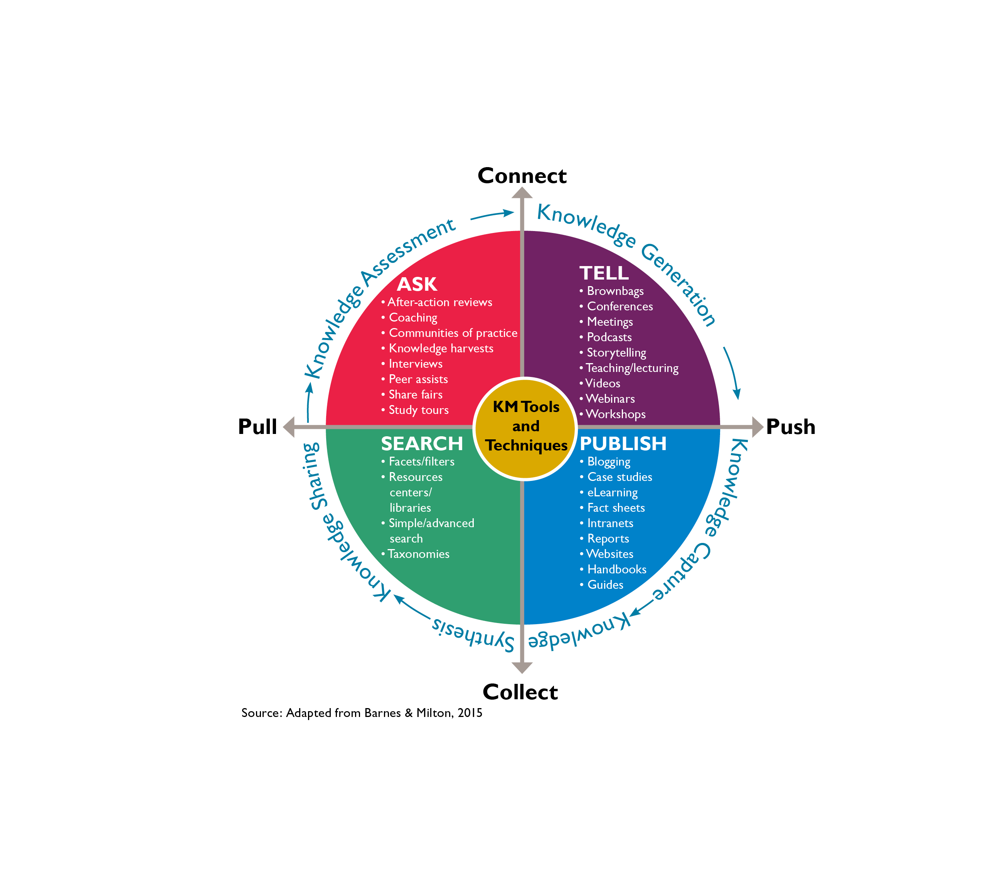

KM Tools and Techniques are measured by Reach, Engagement, Usefulness:
- Reach refers to the breadth (how far out) and saturation (how deep) of your dissemination, distribution, and knowledge-exchange efforts.
- Engagement relates to users’ interactions with other users and to their connection with the knowledge presented.
- Usefulness is determined by two factors: satisfaction and quality. Satisfaction reflects the user’s evaluation of the relevance of the content of the KM output and also of the presentation and delivery mechanism. Quality refers to whether the KM activities are accurate, authoritative, objective, current, and covering the intended scope.

Exercise Worksheet
Quadrant: ________________________

Tool/technique, indicator, and data source

- Tool/technique___________________________________________________________
Indicator ________________________________________________________________
Data source: _____________________________________________________________
- Tool/technique___________________________________________________________
Indicator ________________________________________________________________
Data source: _____________________________________________________________

- Tool/technique ___________________________________________________________
Indicator ________________________________________________________________
Data source: _____________________________________________________________

- Tool/technique ___________________________________________________________
Indicator ________________________________________________________________
Data source: _____________________________________________________________

- Tool/technique ___________________________________________________________
Indicator ________________________________________________________________
Data source: _____________________________________________________________

