Exercise:

Planning a Share Fair
Overview
Share Fairs are participatory events that enable participants to gain new skills and understanding and to learn from other participants. For Share Fairs to be successful, they need to be well planned, and the topic needs to be responsive to a need expressed by the target audience. Prior to holding a Share Fair, it is important to determine the following: the audience(s), the main issues that need to be discussed, the goal for the event, and the knowledge management (KM) tools and techniques your event will include. This is the groundwork for the Share Fair, which is covered in this exercise. Information discussed in this exercise can then be used to draft a concept note, design an agenda, and plan logistics for the Share Fair.
Objectives
- To determine if a Share Fair is needed
- To determine the audience for the Share Fair
- To determine the topic and overall goal for the Share Fair
- To brainstorm KM tools and techniques that can be used for the Share Fair (for example, storytelling, knowledge cafés, speed consulting, etc.)
Time
Total: 45 minutes
Implementing the Activity
- The Trainer will need 5 minutes to explain the activity and to allow participants to pair up with someone else or to form small groups.
- The small groups will spend 30 minutes working on the exercise. Print and pass out the Exercise Worksheet at the end of this document to help participants keep track of their ideas.
- All the participants will regroup at the end of the session for 10 minutes to summarize the key takeaways from the small-group discussions.

Activity Steps
Working in pairs or small groups:
- Think about why a Share Fair is needed. Does your organization or project need additional focus to address a stubborn challenge or accelerate progress? Have you held conferences or symposia that were too formal to adequately capture potential solutions and common challenges?
- Think about the audience of your Share Fair. Will you include multiple audiences (e.g., policy makers and service providers) or will it be focused on one job function? Make sure the audience will have relevant experience to share about the topic.
- Think about the topic you will cover in your Share Fair to meet an expressed need. What need is your event going to address? Make sure the topic is broad enough to appeal to the audience but narrow enough that they would be able to have a good understanding of the topic by the end of the event. Make sure the topic addresses an expressed need from your audience.
- Choose three to five KM tools or techniques to use in your Share Fair. What tools or techniques would appeal most to this audience? Keep your audience’s comfort levels in mind. For example, Share Fairs among young people may include more creative approaches than those among policy makers or ministers of health. Participants can refer to the illustrative KM tools and techniques in the Appendix at the end of this document (print copies ahead of time for the participants) and/or to the Liberating Structures website (http://www.liberatingstructures.com/) for more innovative ideas to elicit participation and to maximize learning.
- Consider logistics/event planning. If time permits, ask the participants to start considering some of the logistical details: What would be a suitable location for the event? A central location close to where most participants live/work? Or would an unconventional location that is not too close to where most participants work be more conducive to getting the participants’ attention? Which particular venue would be most suitable? A hotel, conference center, partner organization, community hall? Does the venue have enough space to accommodate the activities you plan to undertake? Identify the dates for the event. What is the ideal length of time? Consider local holidays and other major events. Finally, are there are other collaborating organizations you can bring on board to help plan and organize the Share Fair?

Report out:
The small groups should share with the larger group the goal, audience, topic, and KM tools and techniques for their proposed event. The group can provide feedback, specifically about whether the proposed approach will address the specific need expressed and the merits and challenges to using different KM tools and techniques during the event to elicit knowledge sharing and maximize learning.

Exercise Worksheet
Goal of the Proposed Share Fair:

Audiences: (consider how many people should attend, what background they should have, from which locations, etc.)

Topic(s):

KM Tools and Techniques:
1.
2.
3.
4.
5.

Potential Location and Venue:

Possible Collaborating Organizations:

Dates:

APPENDIX. Illustrative KM Tools and Techniques
(extracted from K4Health’s How to Hold a Successful Share Fair)

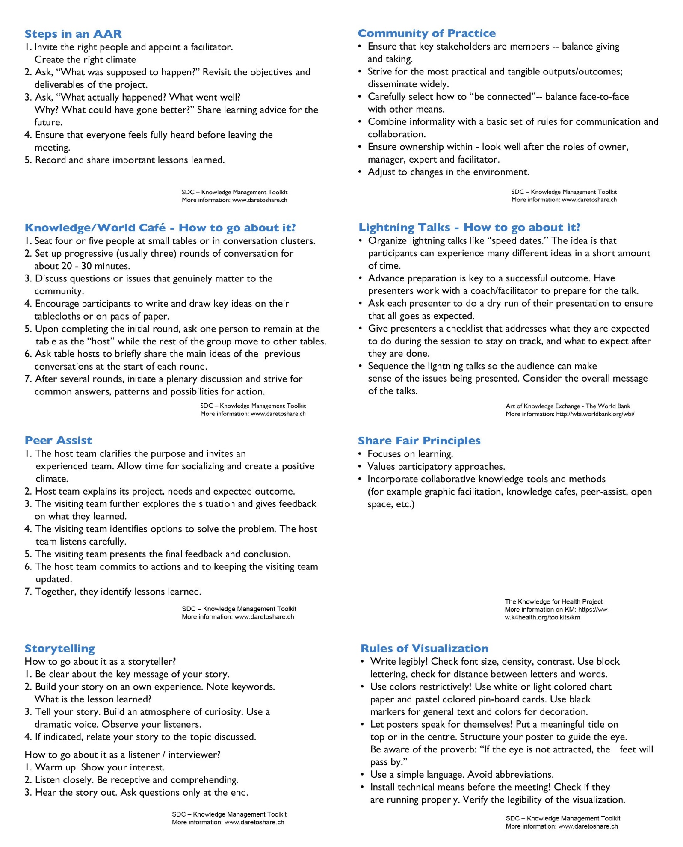

After Action Review
An after action review (AAR) is a discussion of a project or an activity. It enables the individuals involved to explore what happened , why it happened , what went well, what needs improvement, and what lessons can be learned from the experience. The spirit of an AAR is one of openness and learning -- it is not about problem fixing or allocating blame. Lessons learned may be tacitly shared on the spot by the individuals involved or explicitly documented and shared with a wider audience.

Knowledge/World Cafe
In a Knowledge/World Cafe, small groups seated around tables discuss different themes in several rounds. The format is flexible and adapts to foster collaborative dialogue.
- Clarify the purpose! Why are you bringing people together? Create a hospitable space, from the invitation to the physical set-up.
- Explore questions that matter to the participants! Explore a single question, or several questions in progressive steps.
- Encourage everyone's contribution, from actively contributing ideas and perspectives to active listening.
- Connect diverse perspectives by moving to different tables. Listen for insights and share discoveries. After several rounds be sure to meet as a larger group.

Peer Assist
Peer Assist is the most economical way of designing a project and avoiding errors and mistakes based on others' experience and knowledge. A team starting up a new project or task (the hosts) call on another team having acquired experience rather than having to reinvent the wheel. It is worth using Peer Assist when: a team is facing a challenge, where the knowledge and experience of others will really help, and when the potential benefits outweigh the costs of travel.

Storytelling
Storytelling is used in organizations as a communication tool to share knowledge with inspiration. The language used is authentic (focused on experiences rather than facts). Most people find the narrative form interesting and attractive. While storytelling has of course existed for thousands of years as a means of exchanging information and generating understanding, it is quite new as a deli berate tool for sharing knowledge within organizations. However, it is growing very rapidly, to the extent that it is becoming a favored technique among an increasing number of organizations and individuals.
Community of Practice (CoP)
Six essential aspects of a successful CoP:
- Strong community: Includes active members with lively interest. Member pool is often fluctuating.
- Clear, well-defined domain: Focuses on a specific thematic orientation, relevant and meaningful for all members.
- Linked to practice: The CoP is based on and linked to individual practice of its members.
- Personal motivation: Members give priority to the CoP.
- Mandate: Organizations are interested in concrete outcomes and support members with time and resources.
- Informal structure: The CoP goes beyond organizational structures and links up units within and/or between the organizations.

Lightning Talks
Lightning Talks are a series of short presentations on the same or diverse topics by different speakers lasting a few each as part of a single session.

They may occur virtually or face-to-face, as a moderated activity with each talk lasting five minutes, and/ or with experienced practitioners.
Use this technique to:
- Raise awareness about one or more topics in a short amount of time.
- Report on a project or group results and good practices.
- Enhance individual or group capacity to prepare succinct reports or presentations.
- Offer new perspectives.

Share Fair
A Knowledge Fair or Share Fair is an effective technique for catalyzing sharing experiences and expertise it uses face-to-face participatory techniques to engage a group in conversation around implementation methods that have been effective in participants' work. The event highlights local application of knowledge, and the conversation involves the collaboration of many individuals, not just a select few. The knowledge shared in this setting is later synthesized and shared widely, thus supporting continuous improvement and learning.

Visualization
Visualization is a technique to make presentations and discussions more efficient and effective. The spoken word is supported by a visual representation (text, pictures, graphics, objects, etc.). Current means are beamer or transparencies for presentations, and charts or cards for recording discussions.
This technique:
- Improves focus on the point under discussion.
- Makes the content easier to remember.
- Forces the speaker to prepare in advance and to use precise and concrete arguments.
- Reduces emotional implications in a heated discussion.
- Serves as documentation by recording statements, ideas, results, and to-do list.

