Exercise:
“Choose-Your-Own-Adventure” Content Adaptation
Overview
The abundance of online health content—from eLearning courses to technical guidelines to research papers—provides a tremendous number of opportunities for learning, sharing, and career development. Adaptation is the process of taking existing content and making it suitable for a new use, platform, or audience.
The purpose of this exercise is to provide participants hands-on experience in adapting content—without having to develop it from scratch—to better serve beneficiaries and communities. Participants will discover through “choose-your-own-adventure” scenarios the key content adaptation steps highlighted in K4Health’s guide, Making Content Meaningful.
Objectives
By the end of this activity, participants will be able to:
- Define and name key steps in the adaption process
- Identify important considerations when adapting content
- Identify opportunities to adapt existing materials in your own work
Time
Total: 60 minutes
Advance Preparation/Materials
- Copies of Content Adaptation Guide: https://www.kmtraining.org/sites/default/files/supplement-making-content-meaningful.pdf
- Printouts of “Audience Profile Worksheet” (see Exercise Worksheet section)
- 5 cups or other container, each labeled with categories found in table below
- Popsicle sticks (preferably colored): each category will have corresponding set of “sample characteristics” AND “sample information/knowledge gaps” to be written on popsicle sticks. (Note: Feel free to change/adapt options suggested below!)
- Family Planning Handbook or any other vetted/relevant resource
- Posters, markers, and other writing/drawing implements
*There’s an accompanying slide in the PPT that can be used for this activity.
Sample Characteristics
Audience | Literacy level | Source(s) for health info | Commonly spoken language | Potential challenges
- Midwife  - Community health worker (e.g., ASHA)  - University student  - Youth  - First-time parent | - High literacy  - Low literacy  - Not computer literate | - Community health centers  - Schools  - Word of mouth (from friends and family)  - Internet  - TV  - Radio | - English  - Hindi  - Swahili  - French | - Access to transportation  - Access to internet  - Access to mobile phones  - Limited time, very busy

Sample Information/Knowledge Gaps
- Benefits of family planning
- Types of long-acting methods
- Postpartum family planning for breastfeeding and non-breastfeeding mothers
- Contraceptive side effects
- Men as family planning clients (or Male contraception options)

Implementing the Activity
- 5 min | Welcome/intro: why K4Health developed a Content Adaptation Guide, its purpose and framework, and explanation of the activity.
- 50 min | Group activity and discussion (see activity steps for more details)
  - Participants will break up into groups of 3-5 to “choose-their-own” audience profile, and ultimately build a prototype adapted product based on their audience
- 5 min | Q&A/feedback/comments/takeaways; some possible questions to ask:
  - Was it helpful to work through a systematic approach for adapting content?
    - Are you already using these steps in your work?
  - Do you use a different approach for content adaptation?
  - How can the guide be more useful to you?
  - What did you like about the guide/approach? What didn’t you like?
    - Is anything missing?
Activity Steps
Step 1 (Define the audience): “Choose-Your-Own” Audience Profile [10 min]
- Facilitator should have prepared cans and popsicle sticks, labeled with sample characteristics based on table above. Groups will choose one popsicle stick randomly from each can to start building out their audience profile.
- Participants will use fill out Step 1 of Exercise Worksheet (see below). Tell them that they can elaborate on this person’s profile. Give him or her a name, a country, and any other details/background story that they may want to provide.
- Refer participants to guide’s Activity Sheet 1: Understanding Your Audience (or prepare copies of page 8 ahead of time). Based on audience profile, they will complete activity sheet. Fill in as much as they can.

Step 2 (Knowledge needs assessment): What are the gaps? [5 min]
- Note to them that in the guide, surveys, focus group discussion, and in-depth interviews are listed as ways to conduct a needs assessment, to understand what audience members know/doesn’t know about a particular topic area. However, for this activity, we will randomly choose what the info needs are.
- Prepare one cup with “information/knowledge gap” popsicle sticks. Groups will choose one popsicle stick randomly. Tell participants that these are very general categories and that they could elaborate or be more specific when building out their audience profile. Ask participants to fill in step 2 of the Exercise Worksheet

Step 3 (Learning objectives| What are the desired outcomes?) [5 min]
- Based on the knowledge gap from Step 2, ask participants to create a learning objective. First go over sample objective (in PPT) to determine whether it addresses SMART criteria.
- Participants will develop own SMART objective making sure that it fits the following criteria: Specific, Measurable, Appropriate, Realistic, Timely. Ask participants to fill in step 3 of the Exercise Worksheet.

Step 4 (Evaluate existing content) [3 min]
- Note to them that in guide, we listed various factors to consider when determining whether to use an existing resource: credibility, resource components, relevancy, technology capacity, human capacity. However, for this activity, we will select the resource/content and assume that it’s been evaluated and is appropriate.
- Groups can refer to FP Handbook or another relevant/appropriate resource. Ask participants to fill in step 4 of the Exercise Worksheet.

Step 5 (Determine appropriate delivery format) [5 min]
- Considering everything that they know and learned about their audience, their circumstances, and their needs, ask participants Ask participants to fill in step 5 of the Exercise Worksheet to determine what the format of adapted content will look like in their groups.

Step 6 (Repurpose the content) [10 min or longer if time allows]
- Note to participants that there are three different types of adaptation: cultural context, language, delivery format. In guide, we provide examples of case studies that uses one or a combination of these approaches. So consider what’s appropriate for your context/audience. Guide includes key questions and considerations for how to adapt content. Discuss these in groups, and if time allows, encourage them to build prototype using paper, posters, markers, etc.
- What key elements can be reused and adapted?
- What style and tone will work best for the audience?
- What is the appropriate length and technical depth of the adapted content

Step 7 (Test the adapted content in the delivery format): Group Presentation [10 min]
- Note to them that in guide, we write about the need to iterate/testing. Given that we can’t test this on our hypothetical audience, we’re going to use this group.
- Groups will give brief overview of their audience profiles, knowledge gap, learning objective, delivery format, and how content will be repurposed. Allow time for feedback if time allows.

Overview of remaining steps [5 min]
- Step 8 (Promote and deliver adapted content)
- Step 9 (Evaluate whether learning objective was met)
- Step 10 (Consider scaling up)

Exercise Worksheet (see next four pages)

STEP 1: Define the audience | “Choose-your-own” audience profile

Directions: In groups, you will start building out a profile for your audience by randomly choosing a context (i.e., popsicle stick) for each of the five categories below. Be creative! Feel free to elaborate on the audience profile. You can provide a name, country of origin, and/or any other details/background information.

NAME: _____________________________________________

COUNTRY: _________________________________________

OTHER INFORMATION: _______________________________

__________________________________________________

__________________________________________________

__________________________________________________

AUDIENCE TYPE:

LITERACY LEVEL:

COMMONLY-USED SOURCE(S) FOR HEALTH INFO:

COMMONLY SPOKEN LANGUAGE(S):

POTENTIAL CHALLENGES:

STEP 2: Knowledge Needs Assessment | What are the Gaps?

Directions: In groups, you will “conduct” a needs assessment by randomly choosing an information/knowledge gap (i.e., popsicle stick). Please feel free to elaborate or be more specific for your scenario.

____________________’s INFORMATION/KNOWLEDGE GAP:

____________________________________________________________________________________

____________________________________________________________________________________

____________________________________________________________________________________

____________________________________________________________________________________

STEP 3: Determine Learning Objectives | What are the desired outcomes?

Specific - Is the desired outcome and audience clearly specified?
Measurable - Can the achievement of the objective be quantified and measured?
Appropriate - Is the objective appropriate given the learning intervention?
Realistic - Can the objective be realistically achieved with the available resources?
Timely - In what time period will the objective be achieved?

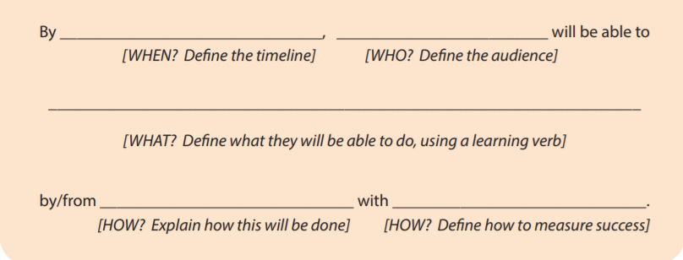
Developing Your Own SMART Objective

STEP 4: Evaluate Existing Content

Directions: Based on the criteria below, pick a resource that is appropriate to adapt for your audience circumstances and knowledge needs.

RESOURCE ____________________________________________________________________________________

____________________________________________________________________________________

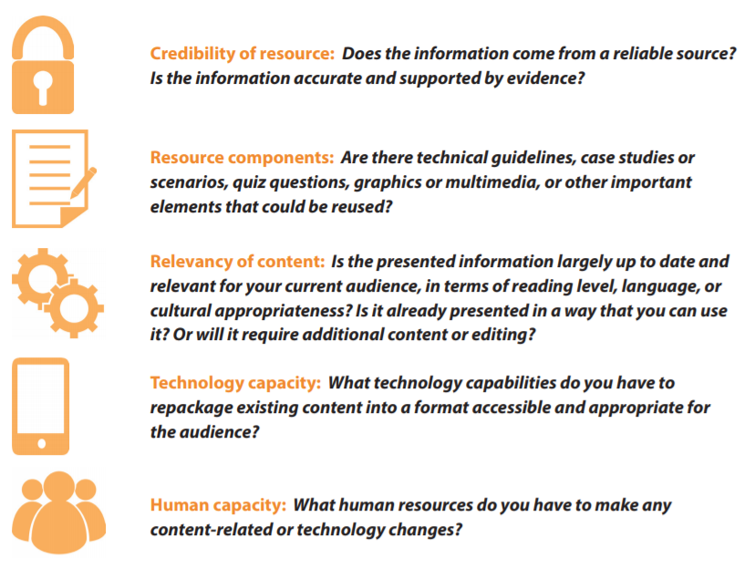

STEP 5: Determine Delivery Format

Directions: In the left column, check the box next to the format that best describes the original content you have. In the right column, check the box(es) next to the format(s) that best describes the format(s) you would like to use to adapt the content. This is your adaptation delivery format.

